**Name – De Silva APC**

**Index – 210098R**

**Group – In21 CSE**

**Assigned Lab Task –**

Main task was to design and develop an (4-bit) Arithmetic unit and then testing it via simulation. The arithmetic unit is deigned to be capable of adding to numbers stored in two registers. This task had the use of the components been designed and developed in previous lab sessions after importing them.

**Conclusions –**

A basic functionality of an Arithmetic logic unit which supports 4 bits. Use of components that already been developed and designed in a larger scale project as modules.

**Screenshots of the simulation(Extended and Archieved) –**

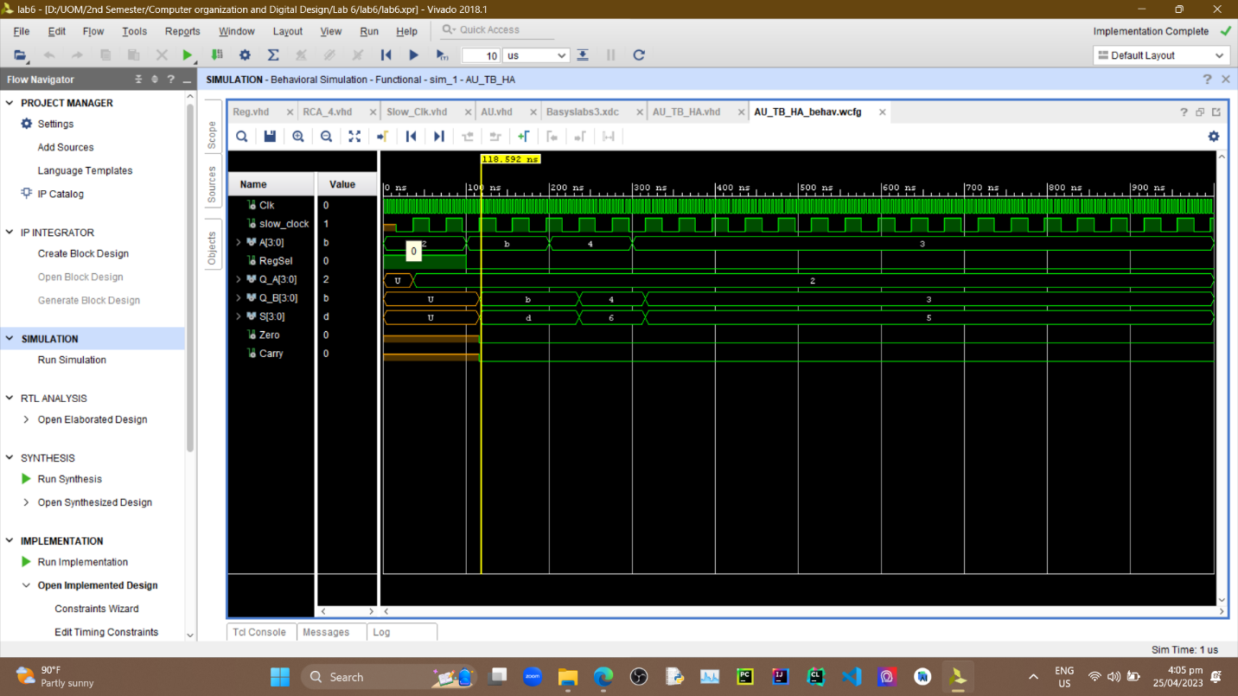

**(Extended) -**

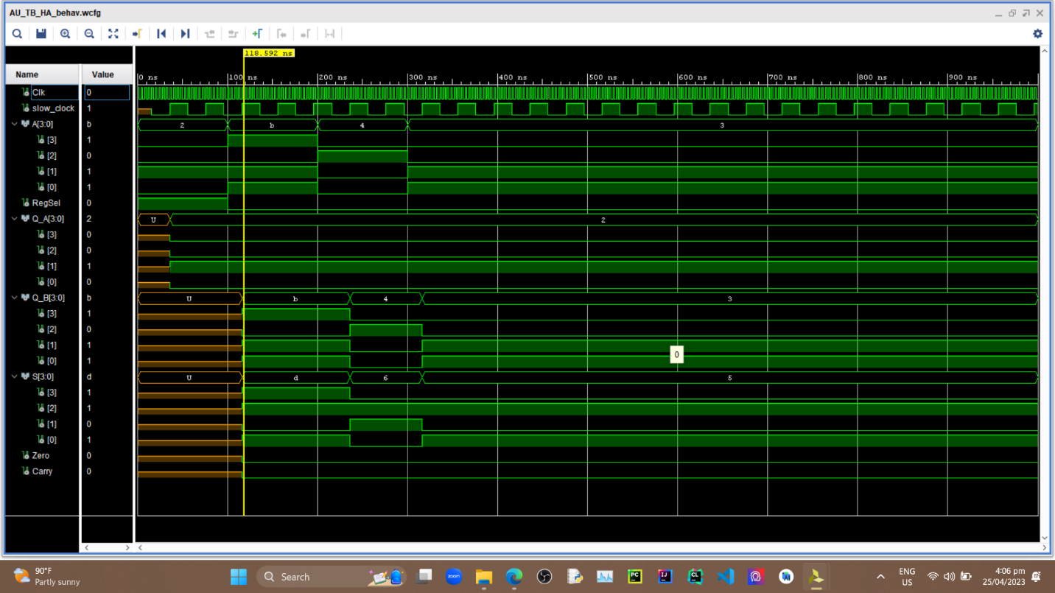

**All VHDL Codes –**

***AU_TB_HA.vhd***

*----------------------------------------------------------------------------------*

*-- Company:*

*-- Engineer:*

*--*

*-- Create Date: 04/25/2023 03:17:04 PM*

*-- Design Name:*

*-- Module Name: AU_TB_HA - Behavioral*

*-- Project Name:*

*-- Target Devices:*

*-- Tool Versions:*

*-- Description:*

*--*

*-- Dependencies:*

*--*

*-- Revision:*

*-- Revision 0.01 - File Created*

*-- Additional Comments:*

*--*

*----------------------------------------------------------------------------------*

*library IEEE;*

*use IEEE.STD_LOGIC_1164.ALL;*

*-- Uncomment the following library declaration if using*

*-- arithmetic functions with Signed or Unsigned values*

*--use IEEE.NUMERIC_STD.ALL;*

*-- Uncomment the following library declaration if instantiating*

*-- any Xilinx leaf cells in this code.*

*--library UNISIM;*

*--use UNISIM.VComponents.all;*

*entity AU_TB_HA is*

*-- Port ( );*

*end AU_TB_HA;*

*architecture Behavioral of AU_TB_HA is*

*component AU*

*Port ( A : in STD_LOGIC_VECTOR (3 downto 0);*

*RegSel : in STD_LOGIC;*

*Clk : in STD_LOGIC;*

*S : out STD_LOGIC_VECTOR (3 downto 0);*

*Zero : out STD_LOGIC;*

*Carry : out STD_LOGIC);*

*end component;*

*signal A,S : STD_LOGIC_VECTOR (3 downto 0) :="0000" ;*

*signal RegSel,Clk,Zero,Carry : STD_LOGIC := '0';*

*begin*

*UUT : AU*

*PORT MAP(*

*A => A,*

*S =>S,*

*Regsel => Regsel,*

*Clk => Clk,*

*Zero => Zero,*

*Carry =>Carry*

*);*

*process*

*begin*

*Clk <= not(Clk);*

*wait for 2ns;*

*end process;*

*process*

*begin*

*A<= "0010";*

*RegSel <= '1';*

*wait for 100ns;*

*RegSel <= '0';*

*A<= "1011";*

*wait for 100ns;*

*A <= "0100";*

*wait for 100ns;*

*A <= "0011";*

*wait;*

*end process;*

*end Behavioral;*

***AU.vhd***

*----------------------------------------------------------------------------------*

*-- Company:*

*-- Engineer:*

*--*

*-- Create Date: 04/25/2023 02:16:58 PM*

*-- Design Name:*

*-- Module Name: AU - Behavioral*

*-- Project Name:*

*-- Target Devices:*

*-- Tool Versions:*

*-- Description:*

*--*

*-- Dependencies:*

*--*

*-- Revision:*

*-- Revision 0.01 - File Created*

*-- Additional Comments:*

*--*

*----------------------------------------------------------------------------------*

*library IEEE;*

*use IEEE.STD_LOGIC_1164.ALL;*

*-- Uncomment the following library declaration if using*

*-- arithmetic functions with Signed or Unsigned values*

*--use IEEE.NUMERIC_STD.ALL;*

*-- Uncomment the following library declaration if instantiating*

*-- any Xilinx leaf cells in this code.*

*--library UNISIM;*

*--use UNISIM.VComponents.all;*

*entity AU is*

*Port ( A : in STD_LOGIC_VECTOR (3 downto 0);*

*RegSel : in STD_LOGIC;*

*Clk : in STD_LOGIC;*

*S : out STD_LOGIC_VECTOR (3 downto 0);*

*Zero : out STD_LOGIC;*

*Carry : out STD_LOGIC);*

*end AU;*

*architecture Behavioral of AU is*

*component Slow_Clk*

*Port ( Clk_in : in STD_LOGIC;*

*Clk_out : out STD_LOGIC);*

*end component;*

*component RCA_4*

*Port ( A0 : in STD_LOGIC;*

*A1 : in STD_LOGIC;*

*A2 : in STD_LOGIC;*

*A3 : in STD_LOGIC;*

*B0 : in STD_LOGIC;*

*B1 : in STD_LOGIC;*

*B2 : in STD_LOGIC;*

*B3 : in STD_LOGIC;*

*C_in : in STD_LOGIC;*

*S0 : out STD_LOGIC;*

*S1 : out STD_LOGIC;*

*S2 : out STD_LOGIC;*

*S3 : out STD_LOGIC;*

*C_out : out STD_LOGIC);*

*end component;*

*component Reg*

*Port ( D : in STD_LOGIC_VECTOR (3 downto 0);*

*En : in STD_LOGIC;*

*Clk : in STD_LOGIC;*

*Q : out STD_LOGIC_VECTOR (3 downto 0));*

*end component;*

*signal slow_clock : STD_LOGIC;*

*signal En_A,En_B,C_out : STD_LOGIC;*

*signal Q_A, Q_B,S_RCA : STD_LOGIC_VECTOR (3 downto 0);*

*begin*

*Slow_Clk_0 : Slow_Clk*

*PORT MAP(*

*Clk_in => Clk,*

*Clk_out => slow_clock*

*);*

*Reg_A : Reg*

*PORT MAP(*

*D=>A,*

*En=>En_A,*

*Clk=>slow_clock,*

*Q =>Q_A*

*);*

*Reg_B : Reg*

*PORT MAP(*

*D=>A,*

*En=>En_B,*

*Clk=>slow_clock,*

*Q =>Q_B*

*);*

*RCA_4_0 : RCA_4*

*PORT MAP(*

*A0=>Q_A(0),*

*A1=>Q_A(1),*

*A2=>Q_A(2),*

*A3=>Q_A(3),*

*B0=>Q_B(0),*

*B1=>Q_B(1),*

*B2=>Q_B(2),*

*B3=>Q_B(3),*

*C_in=>'0',*

*S0=>S_RCA(0),*

*S1=>S_RCA(1),*

*S2=>S_RCA(2),*

*S3=>S_RCA(3),*

*C_out=>C_out*

*);*

*Carry <= C_out;*

*S <= S_RCA;*

*Zero <= not(S_RCA(0)) and not(S_RCA(1)) and not(S_RCA(2)) and not(S_RCA(3) and not(C_out));*

*EN_A <= Regsel;*

*En_B <= Not(Regsel);*

*end Behavioral;*

***Slow_Clk.vhd***

*----------------------------------------------------------------------------------*

*-- Company:*

*-- Engineer:*

*--*

*-- Create Date: 04/08/2023 07:25:00 PM*

*-- Design Name:*

*-- Module Name: Slow_Clk - Behavioral*

*-- Project Name:*

*-- Target Devices:*

*-- Tool Versions:*

*-- Description:*

*--*

*-- Dependencies:*

*--*

*-- Revision:*

*-- Revision 0.01 - File Created*

*-- Additional Comments:*

*--*

*----------------------------------------------------------------------------------*

*library IEEE;*

*use IEEE.STD_LOGIC_1164.ALL;*

*-- Uncomment the following library declaration if using*

*-- arithmetic functions with Signed or Unsigned values*

*--use IEEE.NUMERIC_STD.ALL;*

*-- Uncomment the following library declaration if instantiating*

*-- any Xilinx leaf cells in this code.*

*--library UNISIM;*

*--use UNISIM.VComponents.all;*

*entity Slow_Clk is*

*Port ( Clk_in : in STD_LOGIC;*

*Clk_out : out STD_LOGIC);*

*end Slow_Clk;*

*architecture Behavioral of Slow_Clk is*

*signal count : integer := 1;*

*signal clk_status : std_logic := '0';*

*begin*

*process (Clk_in) begin*

*if(rising_edge(Clk_in)) then*

*count <= count+1;*

*if(count = 5)then -- Counting frequency scaler(Reduced to 5 to simulation purposes.IF not 5M.)*

*clk_status <= not clk_status;*

*Clk_out <= clk_status;*

*count<=1;*

*end if;*

*end if;*

*end process;*

*end Behavioral;*

***RCA_4.vhd***

*----------------------------------------------------------------------------------*

*-- Company:*

*-- Engineer:*

*--*

*-- Create Date: 03/18/2023 11:27:04 AM*

*-- Design Name:*

*-- Module Name: RCA_4 - Behavioral*

*-- Project Name:*

*-- Target Devices:*

*-- Tool Versions:*

*-- Description:*

*--*

*-- Dependencies:*

*--*

*-- Revision:*

*-- Revision 0.01 - File Created*

*-- Additional Comments:*

*--*

*----------------------------------------------------------------------------------*

*library IEEE;*

*use IEEE.STD_LOGIC_1164.ALL;*

*-- Uncomment the following library declaration if using*

*-- arithmetic functions with Signed or Unsigned values*

*--use IEEE.NUMERIC_STD.ALL;*

*-- Uncomment the following library declaration if instantiating*

*-- any Xilinx leaf cells in this code.*

*--library UNISIM;*

*--use UNISIM.VComponents.all;*

*entity RCA_4 is*

*Port ( A0 : in STD_LOGIC;*

*A1 : in STD_LOGIC;*

*A2 : in STD_LOGIC;*

*A3 : in STD_LOGIC;*

*B0 : in STD_LOGIC;*

*B1 : in STD_LOGIC;*

*B2 : in STD_LOGIC;*

*B3 : in STD_LOGIC;*

*C_in : in STD_LOGIC;*

*S0 : out STD_LOGIC;*

*S1 : out STD_LOGIC;*

*S2 : out STD_LOGIC;*

*S3 : out STD_LOGIC;*

*C_out : out STD_LOGIC);*

*end RCA_4;*

*architecture Behavioral of RCA_4 is*

*component FA*

*port(*

*A: in std_logic;*

*B: in std_logic;*

*C_in : in std_logic;*

*S: out std_logic;*

*C_out : out std_logic);*

*end component;*

*SIGNAL FA0_S, FA0_C , FA1_S,FA1_C, FA2_S, FA2_C, FA3_S, FA3_C*

*: std_logic;*

*begin*

*FA_0 : FA*

*port map (*

*A => A0,*

*B => B0,*

*C_in => '0',*

*S=> S0,*

*C_out => FA0_C);*

*FA_1 : FA*

*port map (*

*A => A1,*

*B => B1,*

*C_in => FA0_C,*

*S=> S1,*

*C_out => FA1_C);*

*FA_2 : FA*

*port map (*

*A => A2,*

*B => B2,*

*C_in => FA1_C,*

*S=> S2,*

*C_out => FA2_C);*

*FA_3 : FA*

*port map (*

*A => A3,*

*B => B3,*

*C_in => FA2_C,*

*S=> S3,*

*C_out => C_out);*

*end Behavioral;*

***Reg.vhd***

*----------------------------------------------------------------------------------*

*-- Company:*

*-- Engineer:*

*--*

*-- Create Date: 04/25/2023 02:01:44 PM*

*-- Design Name:*

*-- Module Name: Reg - Behavioral*

*-- Project Name:*

*-- Target Devices:*

*-- Tool Versions:*

*-- Description:*

*--*

*-- Dependencies:*

*--*

*-- Revision:*

*-- Revision 0.01 - File Created*

*-- Additional Comments:*

*--*

*----------------------------------------------------------------------------------*

*library IEEE;*

*use IEEE.STD_LOGIC_1164.ALL;*

*-- Uncomment the following library declaration if using*

*-- arithmetic functions with Signed or Unsigned values*

*--use IEEE.NUMERIC_STD.ALL;*

*-- Uncomment the following library declaration if instantiating*

*-- any Xilinx leaf cells in this code.*

*--library UNISIM;*

*--use UNISIM.VComponents.all;*

*entity Reg is*

*Port ( D : in STD_LOGIC_VECTOR (3 downto 0);*

*En : in STD_LOGIC;*

*Clk : in STD_LOGIC;*

*Q : out STD_LOGIC_VECTOR (3 downto 0));*

*end Reg;*

*architecture Behavioral of Reg is*

*begin*

*process (Clk) begin*

*if (rising_edge(Clk)) then -- respond when clock rises*

*if En = '1' then -- Enable should be set*

*Q <= D;*

*end if;*

*end if;*

*end process;*

*end Behavioral;*

**THE END OF THE REPORT**